**Lab Exercise – I**

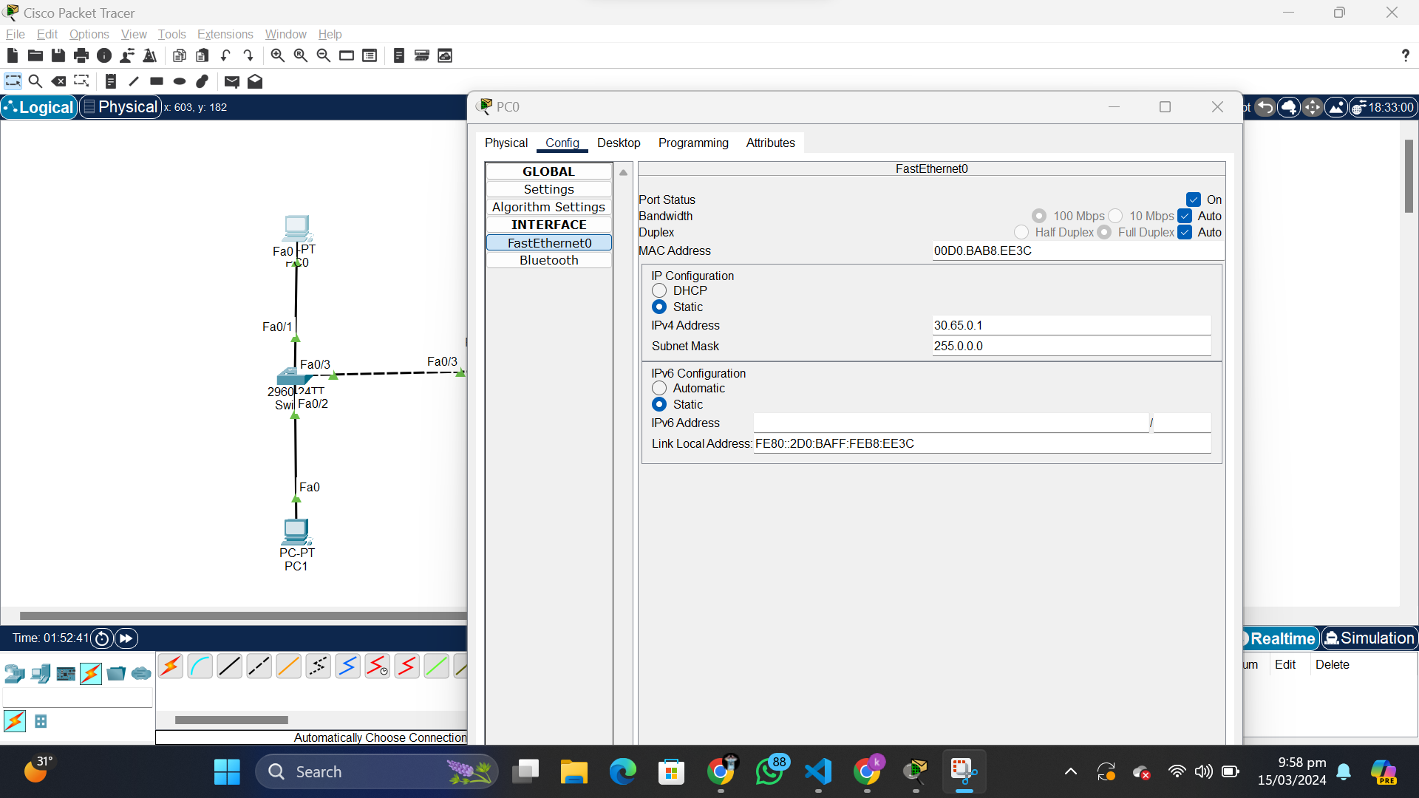

* Ping the server from any computer.

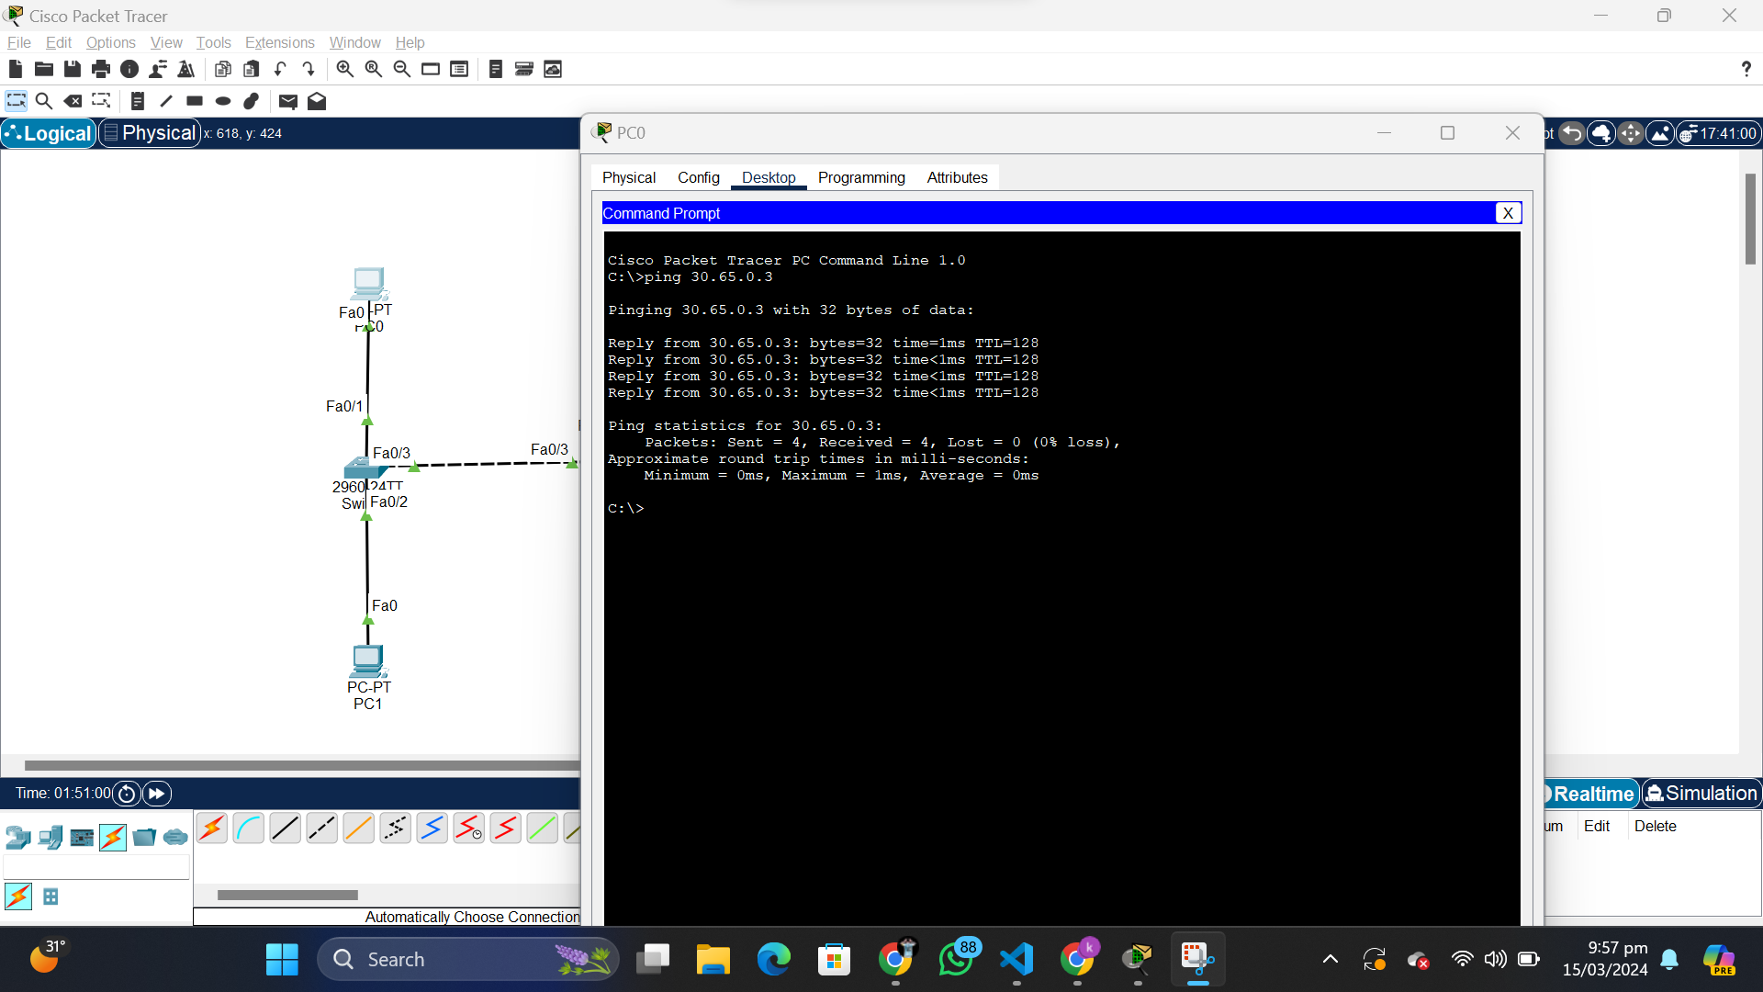

* Verify the telnet connection from all switches nearest to the computer.

Switch0

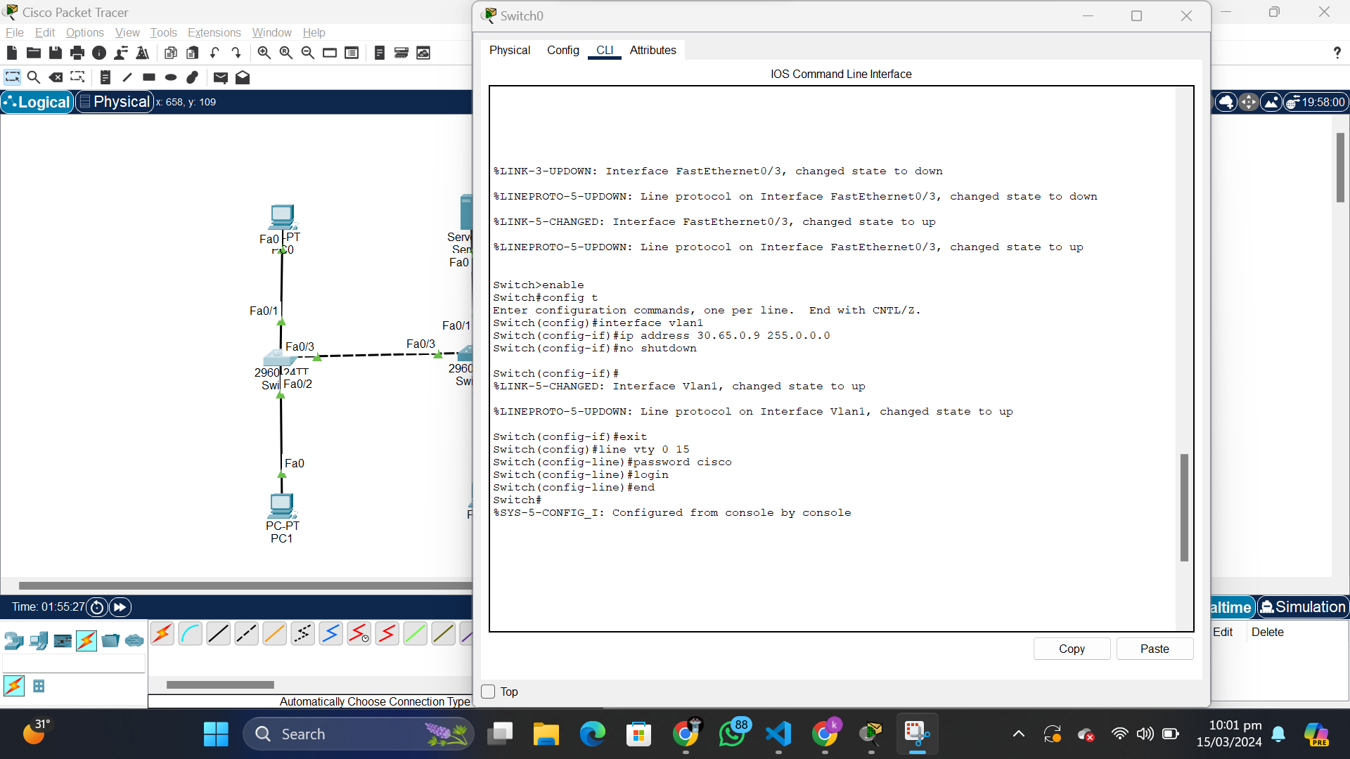

Switch1

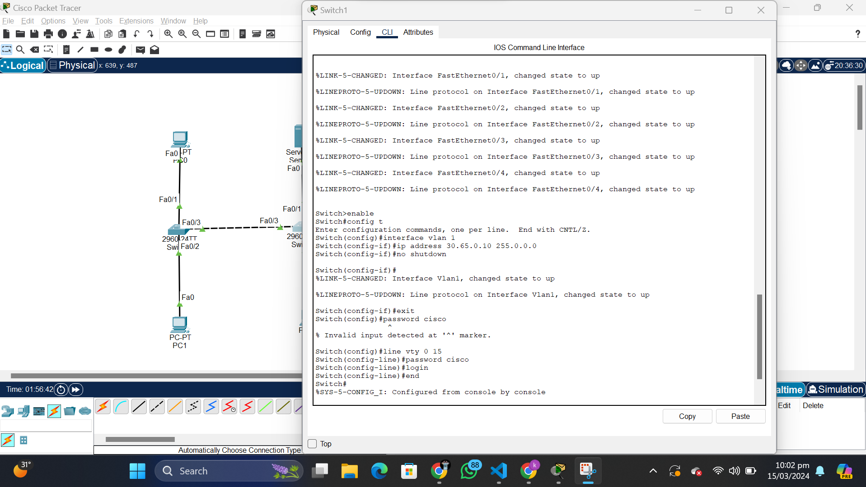

Switch2

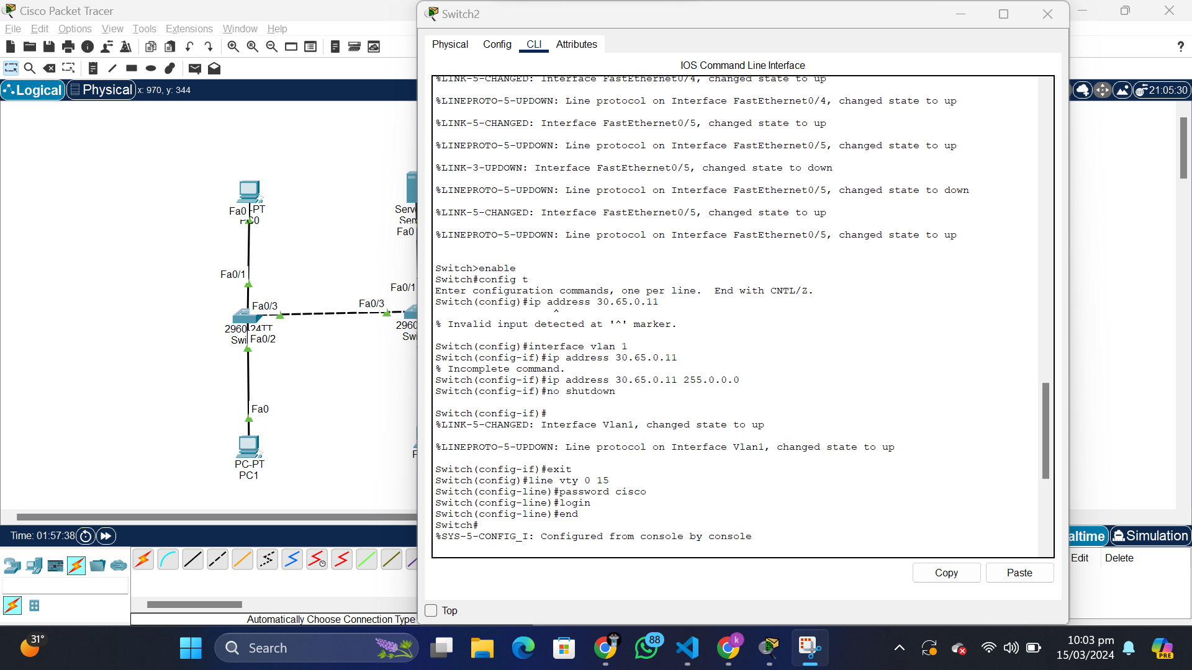

* Do change the IP of Switch2 from PC2 using its command prompt.

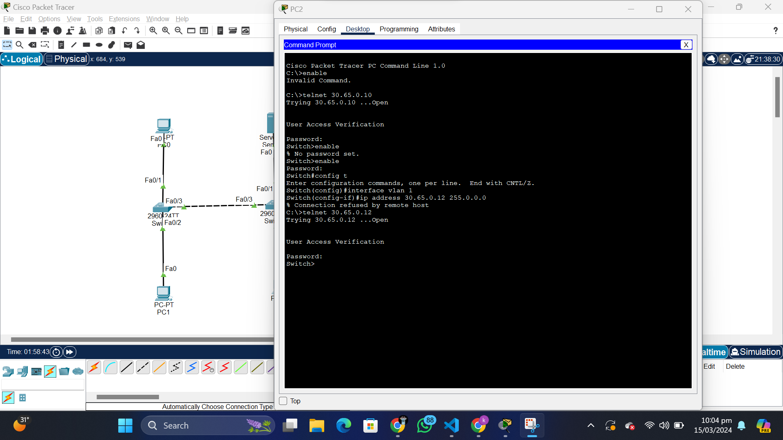

**Lab Exercise – II**

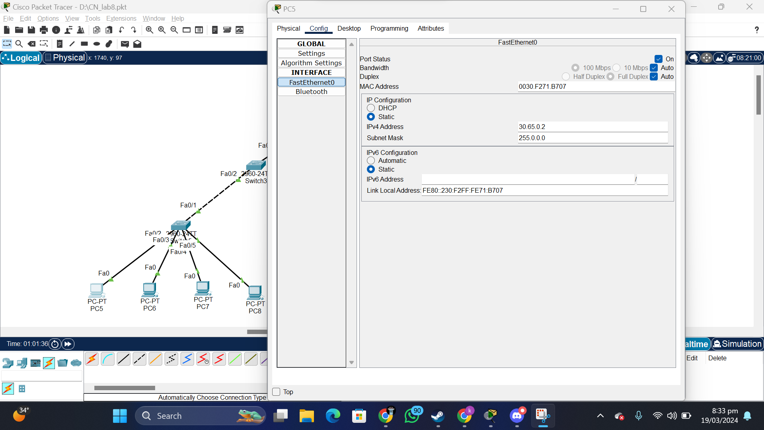

* Assign IP to the router using CLI. The Network should be 65.0.0.X.

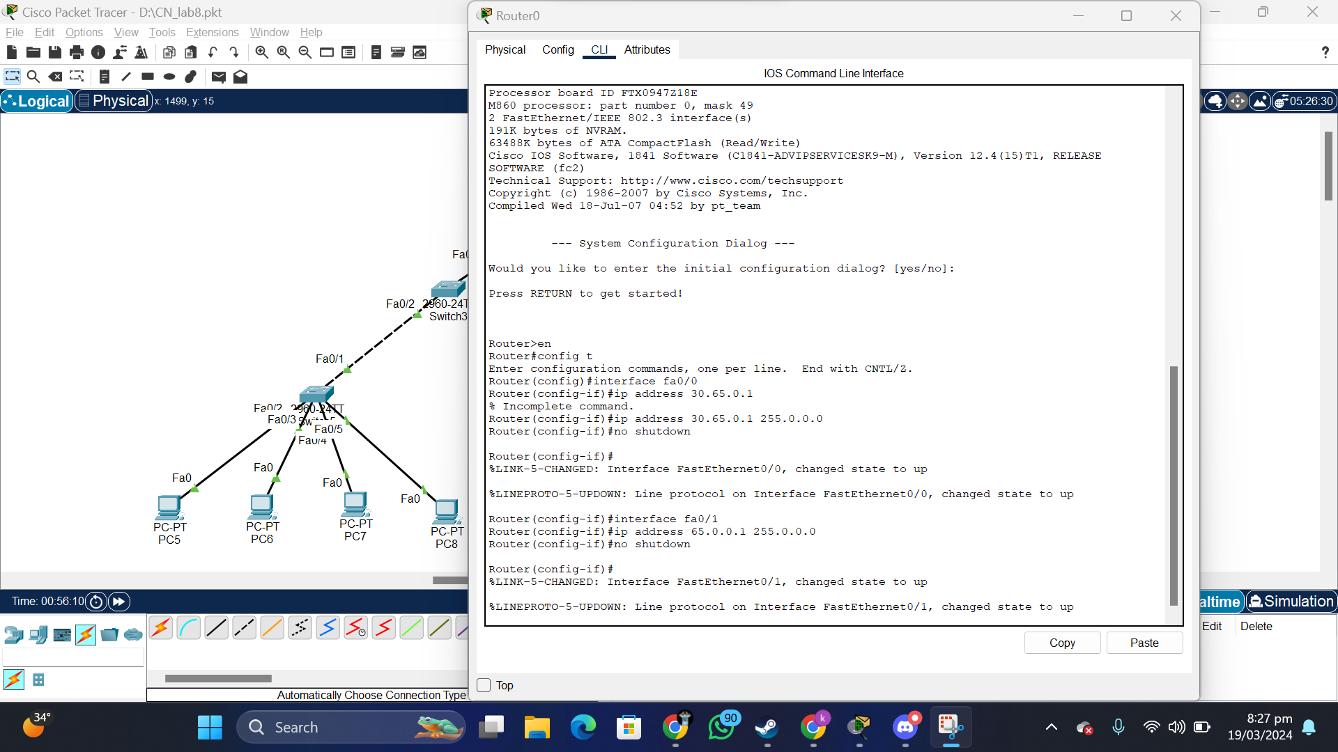

* Configuring Switch

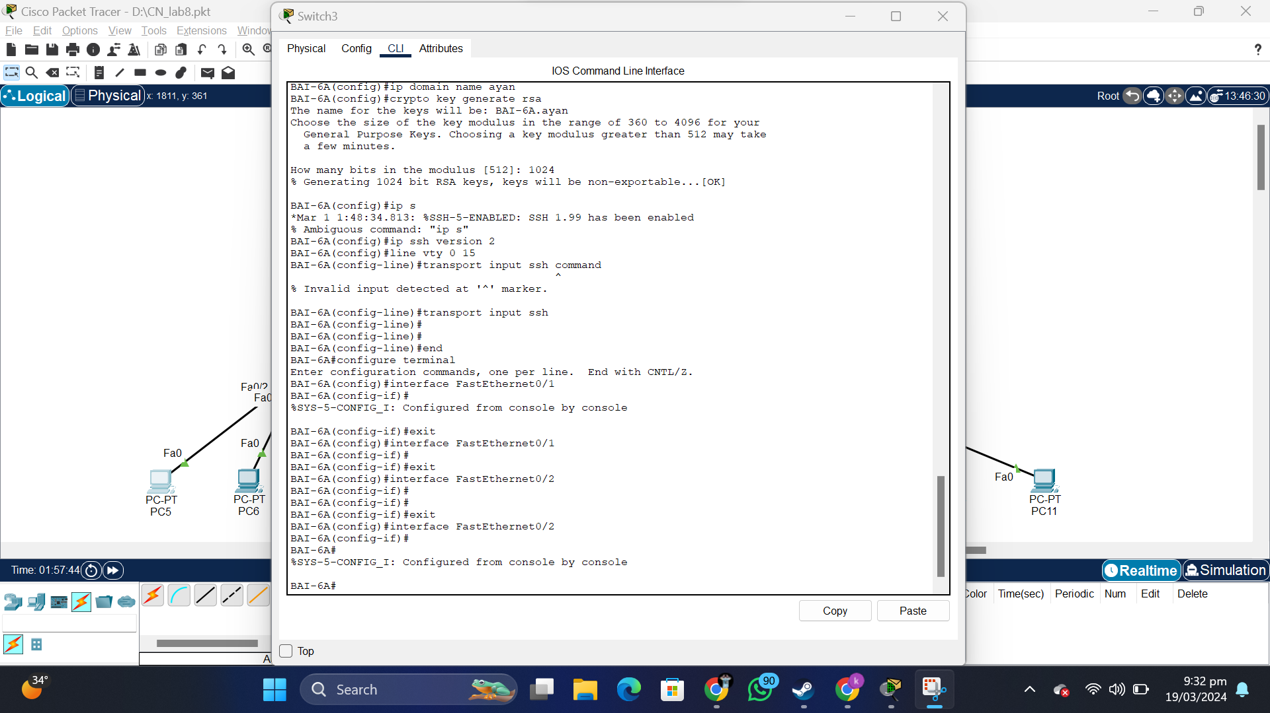

* Verifying SSH and assigning IP to another interface of Router.

